East End Coastal Sweep Beach Clean Up List

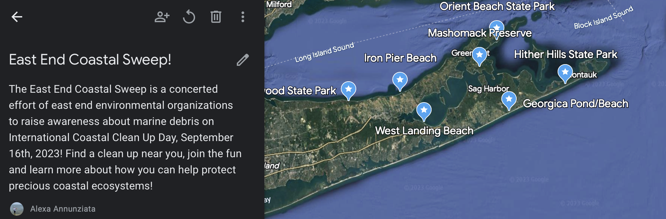

The Nature Conservancy
Mashomack Preserve, Shelter Island
RSVP to MashomackPreserve@tnc.org
Mashomack Preserve, Shelter Island Cleanup will take place 9-11.
We will need to meet at our Visitor Center parking lot and then we'll drive to our location.

NYS Parks
Wildwood State Park
Starts 9:30am
(631)929-4314
No sign up
790 Hulse Landing Rd, Wading River, NY 11792

Hither Hills State Park
Start 9:00am
(631) 668-2554
No sign up
164 Old Montauk Highway, Montauk, NY 11954

Orient Beach State Park
40000 Main Road (Route 25)
Orient, NY 11957
(631) 323-2440

NFEC
Iron Pier Beach
8:00 AM to 10:00 AM
(631) 298 8880
office@nfec1.org
No sign up
Pier Ave, Jamesport, NY 11947

Breakwater Beach
1:00pm to 3:00pm
(631) 298 8880
office@nfec1.org
No sign up
Luthers Rd Mattituck

Peconic Baykeeper and Peconic Estuary Partnership
West Landing Beach
W Landing Rd, Hampton Bays, NY 11946
9:00am to 11:00am
Alexa@peconicbaykeeper.org
Please sign up on our website, google form on event info page
https://peconicbaykeeper.org/event/east-end-coastal-sweep/

